



ML Ops & Containerization
LAB MANUAL

Disclaimer: The content is curated from online/offline resources and used for educational purpose only
Cloud Deployment of a Customer Churn Prediction API Using Render
Objective
To deploy a Customer Churn Prediction REST API on the Render cloud platform and make it publicly accessible for real-time prediction services.
Problem Statement
A telecom company has developed a machine learning model to predict customer churn. Deploy the FastAPI application on the Render cloud platform so that customer service applications can access the prediction API through a publicly available URL.
Requirements
- Python 3.x
- GitHub Account
- Render Account
- FastAPI
- Uvicorn
- Scikit-learn
- Pandas
- Joblib
- Customer Churn Dataset
- VS Code
- Internet Connection

Project Structure
customer-churn-api/
│
├── app.py
├── train_model.py
├── customer_churn.xlsx
├── churn_model.joblib (created after training)
├── requirements.txt
├── README.md
└── .gitignore

Step 1: Review the Customer Churn Dataset
customer_churn.xlsx contains 500 customer records across 20 columns: 19 feature columns describing the customer and their subscription, and one target column, Churn, with values "Yes" or "No".
Step 2: Install Required Libraries
pip install fastapi uvicorn pandas numpy scikit-learn joblib

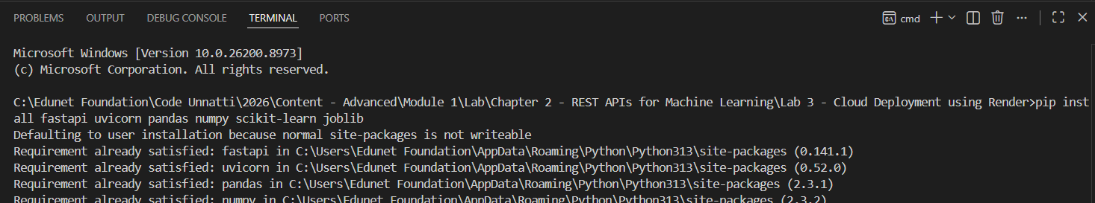
Create requirements.txt:
fastapi
uvicorn
pandas
numpy
scikit-learn
joblib
openpyxl

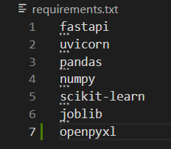
Step 3: Train the Machine Learning Model
Create train_model.py:
import pandas as pd
from sklearn.model_selection import train_test_split
from sklearn.compose import ColumnTransformer
from sklearn.pipeline import Pipeline
from sklearn.preprocessing import OneHotEncoder
from sklearn.ensemble import RandomForestClassifier
import joblib

# 1. Load the dataset
data = pd.read_excel("customer_churn.xlsx")

# 2. Separate features (X) and target (y)
# Use every column except the target, instead of a small hand-picked subset, so the model can use all available signals.
X = data.drop(columns=["Churn"])

# The target is text ("Yes"/"No"); map it to 1/0 for the classifier and so the API's output is unambiguous.
y = data["Churn"].map({"Yes": 1, "No": 0})

# 3. Identify categorical vs. numerical columns
categorical_cols = X.select_dtypes(include=["object", "string"]).columns.tolist()
numerical_cols = X.select_dtypes(exclude=["object", "string"]).columns.tolist()

# 4. Preprocessing: one-hot encode categorical columns
# Contract, InternetService, PaymentMethod and the other text columns cannot be passed directly into RandomForestClassifier, as the original script attempted. handle_unknown="ignore" also protects the live API from crashing on a category value that was not present during training.
preprocessor = ColumnTransformer(transformers=[
("num", "passthrough", numerical_cols),
("cat", OneHotEncoder(handle_unknown="ignore"), categorical_cols),
])

# 5. Combine preprocessing and model into a single pipeline
# Saving preprocessing and the classifier together means app.py does not need to re-implement any encoding logic.
model = Pipeline(steps=[
("preprocessor", preprocessor),
("classifier", RandomForestClassifier(n_estimators=200, random_state=42)),
])

# 6. Split into training and test sets, then train
X_train, X_test, y_train, y_test = train_test_split(
X, y, test_size=0.2, random_state=42, stratify=y
)
model.fit(X_train, y_train)

# 7. Evaluate and save
accuracy = model.score(X_test, y_test)
print(f"Model Trained Successfully. Test Accuracy: {accuracy:.2f}")

joblib.dump(model, "churn_model.joblib")
print("Model Saved Successfully")

Run the script:
python train_model.py

Step 4: Create the FastAPI Application (app.py)
Create app.py:
from fastapi import FastAPI
from pydantic import BaseModel
import pandas as pd
import joblib

app = FastAPI(title="Customer Churn Prediction API")

# Load the trained pipeline once at startup, not per request.
model = joblib.load("churn_model.joblib")

@app.get("/")
def home():
"""Simple health-check endpoint."""
return {"message": "Customer Churn Prediction API Running"}

# Request schema: every feature the model was trained on.
class CustomerRecord(BaseModel):
Gender: str
SeniorCitizen: int
Partner: str
Dependents: str
Tenure: int
PhoneService: str
MultipleLines: str
InternetService: str
OnlineSecurity: str
OnlineBackup: str
DeviceProtection: str
TechSupport: str
StreamingTV: str
StreamingMovies: str
Contract: str
PaperlessBilling: str
PaymentMethod: str
MonthlyCharges: float
TotalCharges: float

@app.post("/predict")
def predict(customer: CustomerRecord):
# Convert the validated request body into a single-row DataFrame. Column names must match those seen in training, since the saved pipeline selects columns by name.
row = pd.DataFrame([customer.dict()])

# The pipeline re-applies the same one-hot encoding used during training, so text fields can be passed in as-is.
prediction = model.predict(row)[0]
probability = model.predict_proba(row)[0][1]

result = "Customer Will Leave" if prediction == 1 else "Customer Will Stay"

return {
"Prediction": result,
"churn_probability": round(float(probability), 2),
}

Step 5: Create README.md
# Customer Churn Prediction API

This project predicts whether a telecom customer is likely to leave the
company using a Random Forest machine learning model, served with FastAPI
and deployed on Render.
## Run Locally
pip install -r requirements.txt
python train_model.py
uvicorn app:app --reload

## API
- GET / health check
- POST /predict returns a churn prediction for a JSON customer record

Step 7: Create .gitignore
Add a .gitignore so local environment files and caches are not pushed to GitHub:
__pycache__/
*.pyc
.venv/
venv/
.env
.vscode/

Step 8: Test the API Locally
Start the API:
uvicorn app:app --reload

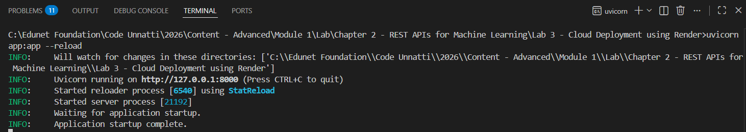
Open the interactive documentation:
http://127.0.0.1:8000/docs

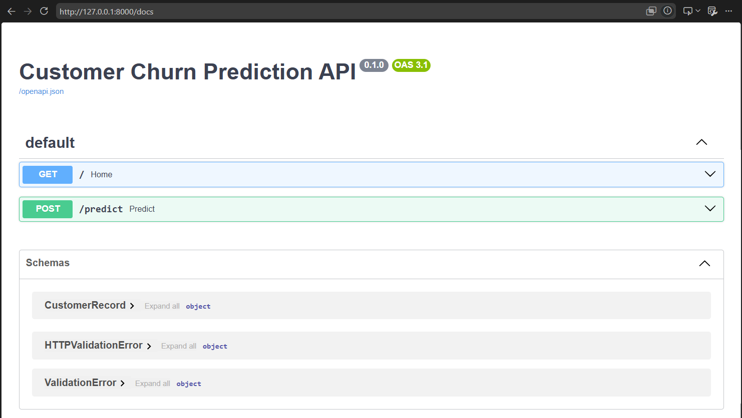
Click POST /predict, then Try it out, and use a sample request body such as:
{
"Gender": "Male",
"SeniorCitizen": 0,
"Partner": "Yes",
"Dependents": "No",
"Tenure": 46,
"PhoneService": "Yes",
"MultipleLines": "Yes",
"InternetService": "No",
"OnlineSecurity": "Yes",
"OnlineBackup": "Yes",
"DeviceProtection": "No internet service",
"TechSupport": "Yes",
"StreamingTV": "No",
"StreamingMovies": "No",
"Contract": "Month-to-month",
"PaperlessBilling": "Yes",
"PaymentMethod": "Mailed check",
"MonthlyCharges": 70.92,
"TotalCharges": 7708.14
}

Response:
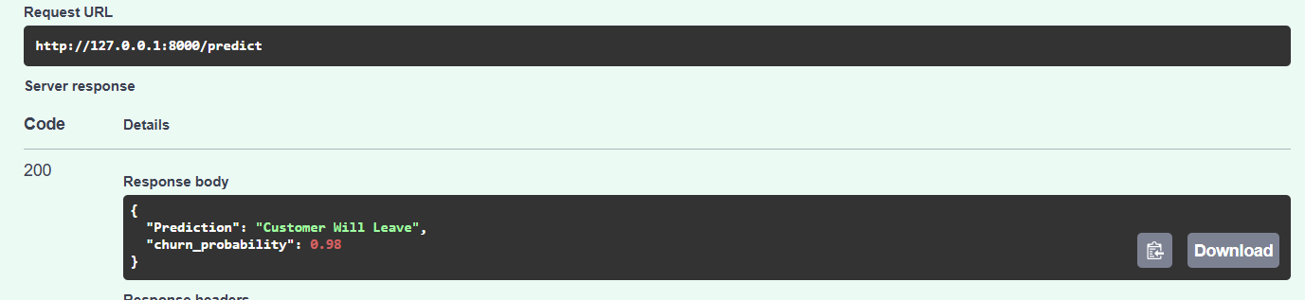

Step 9: Upload the Project to GitHub
Create a new repository on GitHub, then from the project folder:
git init
git add .
git commit -m "Customer Churn Prediction API"
git remote set-url origin https://github.com/<username>/customer-churn-api.git
git branch -M main
git push -u origin main

Repository structure after pushing:
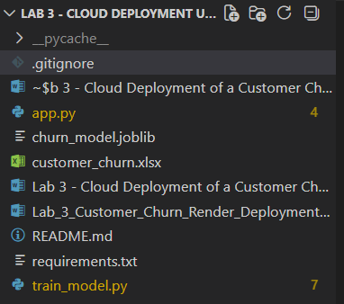
Step 10: Log in to Render
Open the Render dashboard and log in using your GitHub account:
https://dashboard.render.com

Verify the email and start using Render
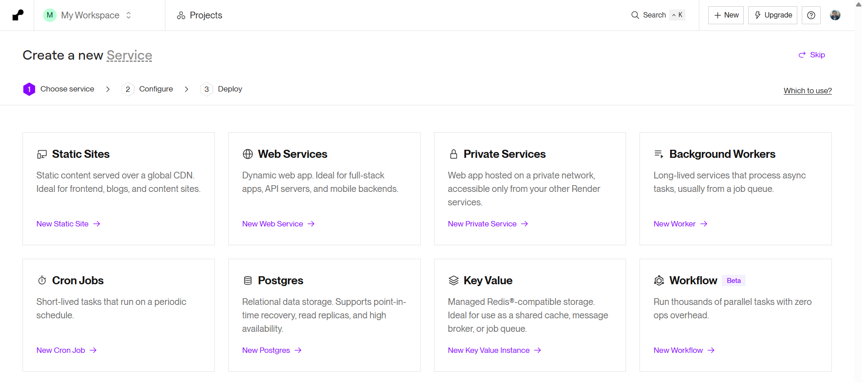
Step 11: Create a New Web Service
From the Render dashboard, search for Web services, and click New Web Service.
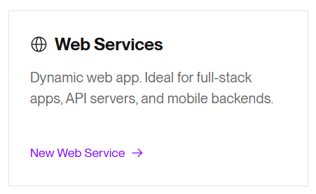
Step 12: Connect the GitHub Repository
Choose the customer-churn-api repository from the list, scroll down and Configure the Runtime Environment
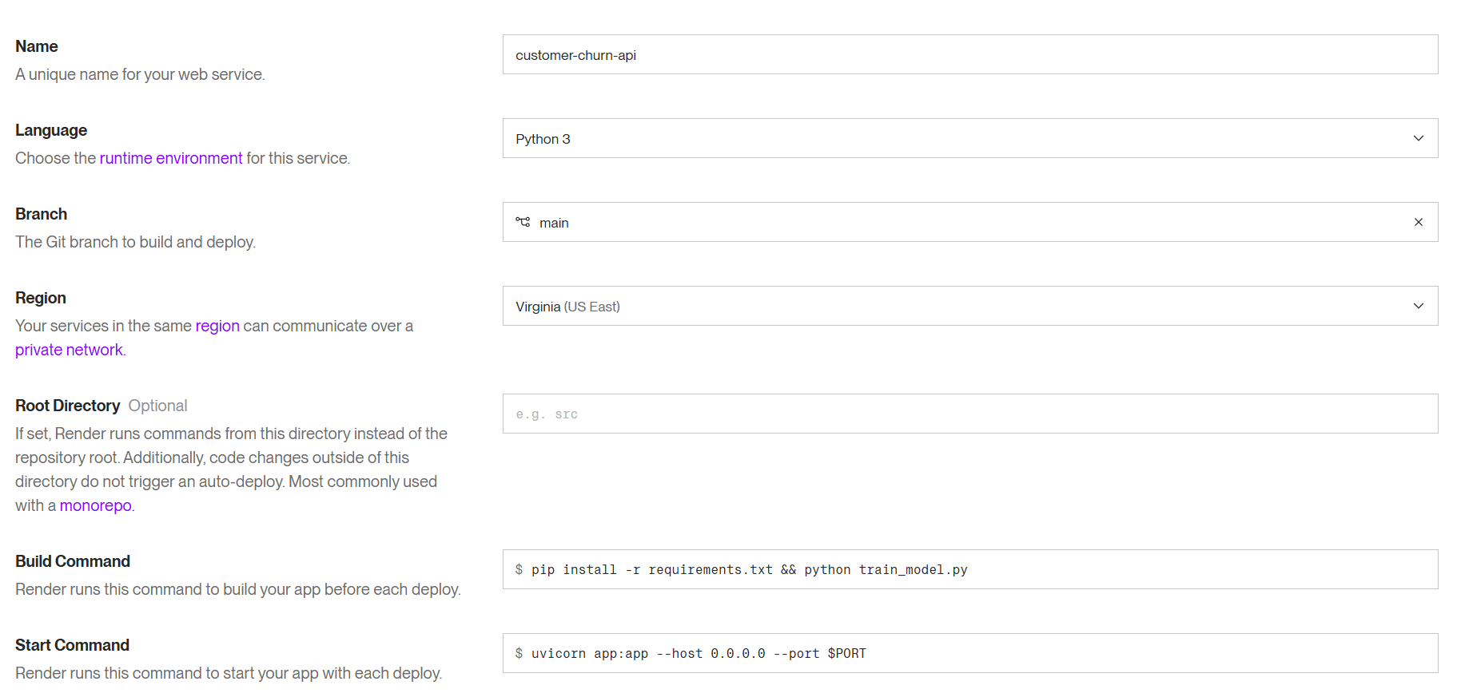
Scroll down and select the Free Plan option before moving forward
Step 14: Deploy the Web Service
Click Deploy Web Service. Render automatically:
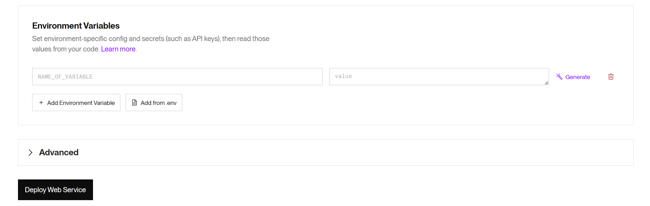
- Clones the GitHub repository
- Installs dependencies
- Builds the application
- Starts the FastAPI server
Example deployment log:
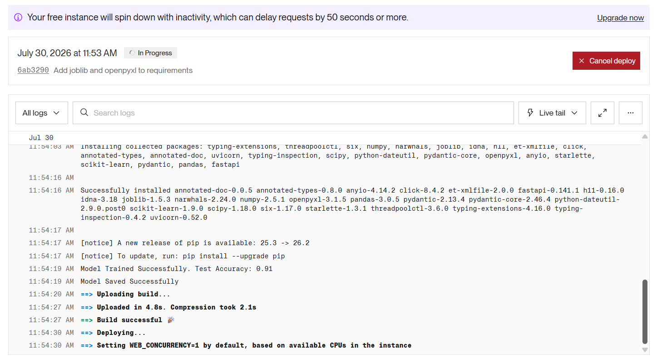

Step 15: Wait for Deployment to Complete
After 2-5 minutes, the service status changes to Live.
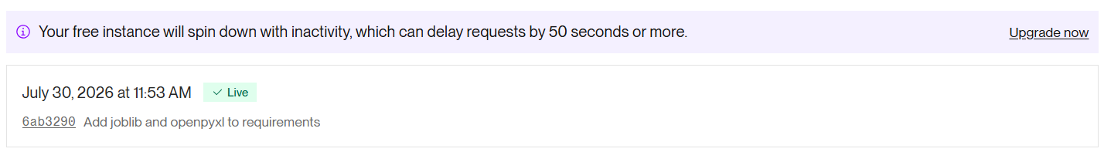
Step 16: Access the Public Application URL and Test the API
Render generates a public URL similar to Home endpoint:
https://customer-churn-api.onrender.com/

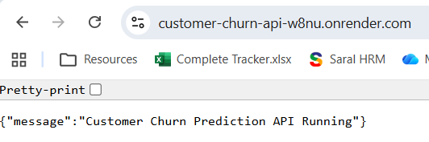

Swagger UI:
https://customer-churn-api-w8nu.onrender.com/docs

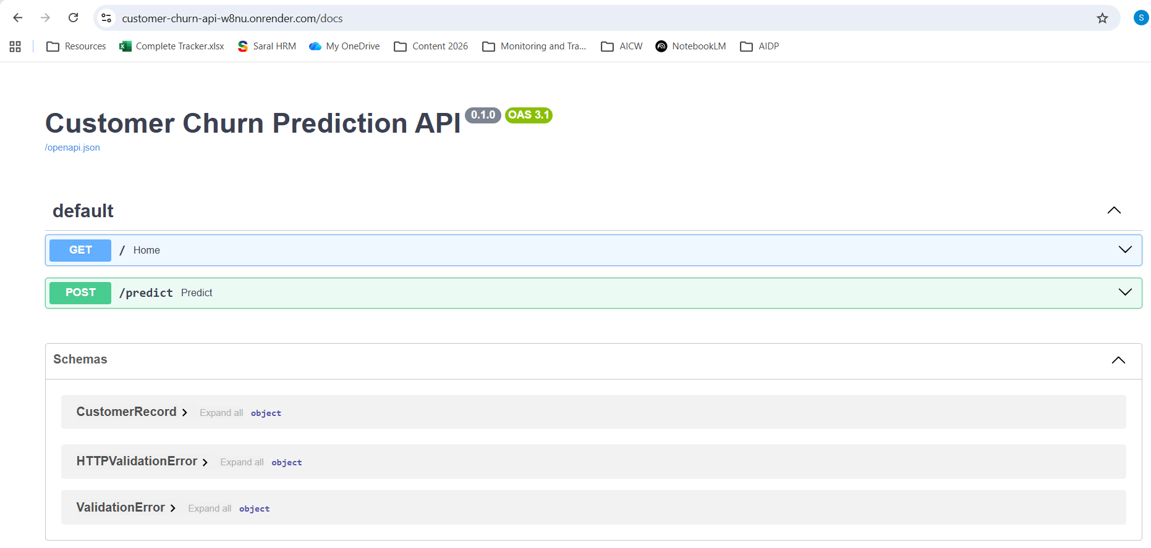
Test POST /predict from Swagger UI using the same sample body as Step 8:
{
"Gender": "Female",
"SeniorCitizen": 1,
"Partner": "No",
"Dependents": "No",
"Tenure": 63,
"PhoneService": "Yes",
"MultipleLines": "No",
"InternetService": "DSL",
"OnlineSecurity": "No",
"OnlineBackup": "No",
"DeviceProtection": "No internet service",
"TechSupport": "No",
"StreamingTV": "No",
"StreamingMovies": "No",
"Contract": "One year",
"PaperlessBilling": "Yes",
"PaymentMethod": "Electronic check",
"MonthlyCharges": 56.39,
"TotalCharges": 2431.61
}

Response:
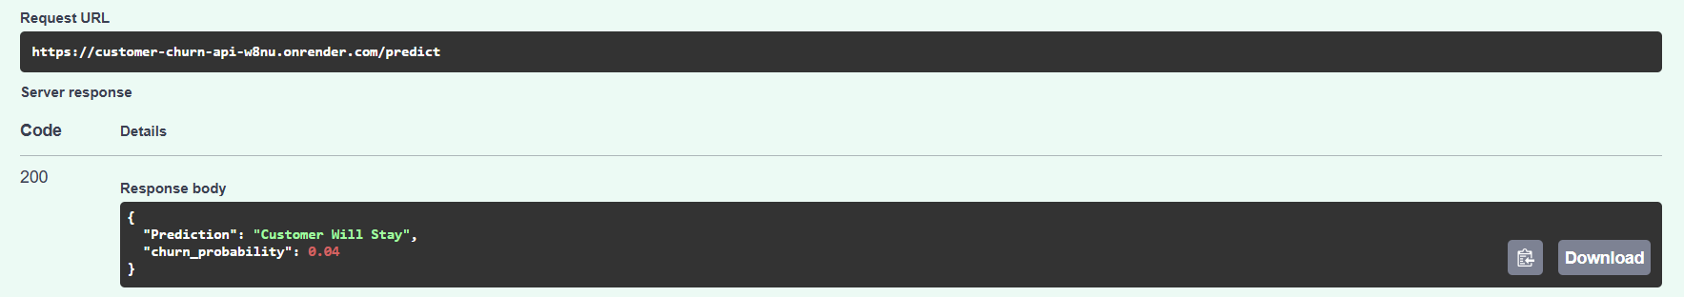
Conclusion
In this lab, a Customer Churn Prediction REST API was built with FastAPI and deployed to the Render cloud platform. The model - a RandomForestClassifier wrapped in a scikit-learn Pipeline that one-hot encodes categorical fields such as Contract, InternetService, and PaymentMethod alongside the numeric fields - was trained on all 19 real feature columns in customer_churn.xlsx rather than a small, partly non-existent subset. The FastAPI application, exposing a POST /predict endpoint validated against a Pydantic schema and a GET / health check, was pushed to GitHub and connected to a Render web service configured with the correct build and start commands. Once live, both the home endpoint and the prediction endpoint were verified through the public Render URL using Swagger UI, confirming that the cloud-hosted API returns the same predictions as the local version.

